​
Preparing Students with Invisible Disabilities for Postsecondary Education: A Structured Review of Self-Advocacy, Navigation, and Access Needs
Eric S. Fishon
Department of Family, Youth and Community Sciences, College of Agricultural and Life Sciences, University of Florida
Co Authors:
Author Note
Eric S. Fishon, Department of Family, Youth and Community Sciences, College of Agricultural and Life Sciences, University of Florida.
This manuscript was prepared as part of a non-thesis master’s project. This study did not involve human subjects, and data collection was not subject to IRB review. The authors declare no conflicts of interest.
Correspondence concerning this article should be addressed to Eric S. Fishon, Department of Family, Youth, and Community Sciences, College of Agricultural and Life Sciences, University of Florida, Gainesville, FL. Email: eric.fishon@ufl.edu

Abstract
Background: Students with invisible disabilities may enter postsecondary education academically capable, while facing a substantial shift in responsibility for disability disclosure, self-advocacy, accommodation navigation, and support use.
Purpose: This structured review examined transition readiness, self-advocacy, navigation, and access needs of students with non-apparent disabilities moving from secondary to postsecondary education.
Method: Fifteen peer-reviewed studies published from 2021 to 2025 were retained through iterative, targeted searches of ERIC, PubMed, and publisher/DOI records, supplemented by citation chaining and seminal developmental theories. Evidence was classified as direct transition, postsecondary-only, contextual, or supporting, and was synthesized narratively across six analytic domains.
Results: Evidence was organized into self-knowledge and barrier articulation, self-advocacy and communication, disclosure/stigma/credibility, navigation and systems knowledge, transfer of responsibility, support implementation, and continuity. Transition emerged as both an environmental change and a change in students’ roles. Direct transition evidence was strongest for self-advocacy, systems navigation, and transfer of responsibility, whereas disclosure and support continuity evidence was stronger after college entry.
Conclusion/Implications: The findings support a developmental approach that increases student leadership while preserving accessible systems and human support. The implications for families, youth-serving professionals, secondary transition personnel, and postsecondary institutions are discussed.
Keywords: nonapparent disability; transition to college; self-advocacy; disclosure; accommodations; higher education

Introduction
The transition from secondary to postsecondary education changes more than just the physical setting in which learning occurs: For students with disabilities, it can also change who is responsible for supporting their needs, initiating accommodation processes, communicating with instructors, understanding institutional procedures, and recognizing when support is not working. These changes may be especially consequential for students with non-apparent disabilities because their access needs are not necessarily visible to others and because disclosure can carry social, emotional, and practical consequences (Kline & Davidson, 2022; Melián & Meneses, 2022; Tontini & Moriña, 2025).
Recent research suggests that students may arrive at college with uneven preparation for this change in their role. Cho and Jones (2024) found variations in disability law knowledge, self-determination, self-advocacy, and campus resource use among students registered with disability offices. Moore et al. (2024) similarly described self-advocacy as a developmental process that unfolded as students moved from extensive K-12 and family support toward greater responsibility in higher education. Direct transition research also identifies new expectations, practical and logistical demands, changing family roles, and the need to balance support and independence (Kim et al., 2021; Parsons et al., 2023).
These findings indicate that postsecondary access cannot be reduced to whether a student has documentation or has been approved for accommodation. Access also depends on whether the student understands their personal needs, can communicate them, can navigate institutional systems, and can recognize when approved support is unavailable, difficult to use, or poorly matched to the context of their needs. Postsecondary studies on accommodation use and implementation reinforce this distinction between approval and effective use (Blasey et al., 2023; Edwards et al., 2022; Tufty et al., 2024).
Despite this growing body of work, no review has synthesized non-apparent disability transition evidence specifically across self-knowledge, self-advocacy, disclosure, navigation, responsibility transfer, and support continuity within a single organizing framework. Prior reviews and individual studies tend to address one domain in isolation — for example, disclosure alone (Tontini & Moriña, 2025) or accommodation implementation alone (Edwards et al., 2022) — leaving the cumulative picture of what changes across the secondary-to-postsecondary transition comparatively underexamined. This gap matters because families, secondary transition personnel, and institutions act on only part of the picture unless the domains are considered together.
This manuscript synthesizes recent evidence concerning transition readiness, self-advocacy, navigation, and access needs for students with non-apparent disabilities moving from secondary to postsecondary education. The primary review question was as follows: What transition readiness, self-advocacy, navigation, and access needs are documented for students with non-apparent disabilities moving from secondary to postsecondary education?
Developmental and Contextual Framing
This review was informed by a contextual developmental perspective of the literature. Bronfenbrenner's bioecological model conceptualizes development as occurring through recurring interactions among the person, processes, contexts, and time. Vygotsky's sociocultural framework emphasizes learning through supported participation and gradual transfer of responsibility. These seminal theories are included because they provide a durable explanation of why transition readiness should not be treated as an individual trait. The student's ability to self-advocate is shaped by family practices, secondary school preparation, disability service procedures, institutional expectations, and opportunities the student has had to practice increasingly independent participation.
Within this framework, independence does not imply the absence of support. Rather, a more developmentally appropriate goal is a shift from advocacy performed for the student to advocacy practiced with the student, increasing student leadership with access to appropriate human and institutional support. This distinction is consistent with recent empirical studies describing changing parent/caregiver relationships and student responsibilities during the transition to college (Kim et al., 2021; Moore et al., 2024).
Arnett's theory of emerging adulthood adds a complementary life-stage perspective. Emerging adulthood describes the late teens through the twenties as a period in which roles, identities, and pathways become less externally structured and more individually negotiated (Arnett 2000). For students entering college, this perspective helps situate increasing responsibility for disability-related decision-making within a broader developmental transition. In this review, emerging adulthood is used as contextual framing rather than as empirical proof that all students experience transitions similarly.
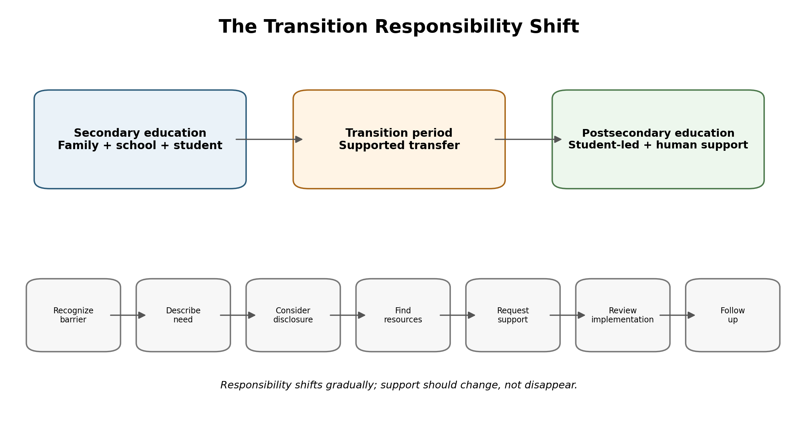
Figure 1. Conceptual model of the gradual shift in responsibility across secondary-to-postsecondary transition. Author synthesis informed by the reviewed transition literature; not a validated developmental model.
Method
Design
This study used a structured evidence synthesis and needs assessment approach. It does not involve recruitment, interviews, surveys, observations, or other live human subject data collection. The synthesis was designed to identify recurring access needs, distinguish direct transition evidence from postsecondary-only evidence, document contradictory or limited findings, and avoid treating the number of publications mentioning a topic as a measure of its importance. Consistent with a structured (rather than systematic) review design, no pre-registered protocol, dual independent screening, or formal quality appraisal tool was used; this distinction is revisited in the Limitations section.
Eligibility Criteria
- Peer-reviewed, published between 2021 and 2026 (older sources retained only as seminal theory or authoritative legal/policy reference).
- Addressed students with disabilities in secondary-to-postsecondary transitions or higher-education settings.
- Evidence was provided on self-advocacy, disclosure, navigation, responsibility transfer, accommodation access, and support implementation.
- Studies focused primarily on generative AI or technology design were excluded from this manuscript and reserved for later manuscripts in the series unless they directly established the need for a transition.
Search and Screening
Evidence identification used iterative, targeted searches of ERIC, PubMed, publisher and DOI records, and citation chaining from relevant peer-reviewed studies, supplemented by a verified evidence ledger maintained for the project. Search concepts combined disability and invisible disability terms with transition to college, higher education, self-advocacy, disclosure, accommodations, navigation, family or responsibility transfer, and support implementation.
This manuscript is a structured review rather than a systematic review and does not claim exhaustive coverage of all eligible studies. Fifteen recent peer-reviewed studies published between 2021 and 2025 were retained for substantive synthesis because they directly addressed one or more review domains (see Table 1). Seminal developmental sources were used only for theoretical framing purposes.
Evidence Extraction and Synthesis
Each retained study was recorded in a controlled evidence matrix containing the source identity, design, population and setting, evidence position, relevant synthesis domain(s), supported observations, limitations, and permissible manuscript use. Evidence was classified as direct transition, postsecondary only, contextual, or supporting. Findings were synthesized narratively across six analytic domains, developed as organizing categories for this review rather than being presented as a validated taxonomy.
Table 1
Table 1. Summary of Retained Evidence (N = 15)
Author (Year) | Design | Population / Setting | Evidence Type | Domain(s) | Key Finding
Blasey, Wang, & Blasey (2023) | Design not specified in current synthesis — verify from source | College students with disabilities receiving accommodations | Postsecondary-only | Domain 6 | Approved accommodations are not always used consistently, and implementation gaps affect outcomes.
Cho & Jones (2024) | Design not specified — verify from source | College students registered with a disability office | Postsecondary-only | Domains 2, 4 | Uneven knowledge of disability law, self-determination, self-advocacy, and campus resource use.
Edwards, Poed, Al-Nawab, & Penna (2022) | Design not specified — verify from source | University students with disabilities | Postsecondary-only | Domain 6 | Universal design principles may reduce the reliance on individualized accommodation processes.
Gartland & Strosnider (2023) | Conceptual / narrative synthesis | Students with learning disabilities transitioning to postsecondary | Direct transition | Domain 4 | Secondary and postsecondary systems differ substantially in terms of self-identification, documentation, and institutional responsibility.
Kim, Crowley, & Bottema-Beutel (2021) | Design not specified — verify from source | Autistic undergraduate students | Direct transition | Domains 4, 5 | Family support, new expectations, and the balance between parental support and independence shape this adjustment.
Kline & Davidson (2022) | Design not specified — verify from source | College students with invisible illnesses/disabilities | Postsecondary-only | Domain 3 | Document disclosure, hiding, and support-seeking experiences.
Melián & Meneses (2022) | Design not specified — verify from source | Online university students with apparent and hidden disabilities | Postsecondary-only | Domain 3 | Disclosure carries emotional risk, and administrative processes can become barriers tied to stigma and credibility concerns.
Moore, Vaccaro, Newman, Daly-Cano, & Brandis Ruise (2024) | Qualitative (implied by first-person quotation in title) — verify from source | College students with disabilities | Direct transition | Domains 2, 5 | Self-advocacy develops as students move from family- and school-supported processes toward independent responsibility.
Nieweglowski, Qin, & Ko (2025) | Randomized controlled trial | College students with disabilities | Postsecondary intervention | Domain 2 | The six-week self-advocacy program was feasible and acceptable, with preliminary gains in disclosure and accommodation-request confidence, but not uniform across outcomes.
Parsons, McColl, Martin, & Reynard (2023) | Qualitative study | Students with disabilities in postsecondary settings | Direct transition | Domains 4, 5 | Students described transition and accommodation experiences that required a more active postsecondary role.
Pfeifer, Reiter, Cordero, & Stanton (2021) | Design not specified — verify from source | Undergraduates with ADHD and/or specific learning disabilities in STEM | Postsecondary-only | Domains 1, 2 | Self-advocacy is shaped by both student-level and environmental/communication factors.
Santhanam & Wilson (2024) | Comparative design (implied) — verify from source | Autistic and non-autistic college students | Postsecondary-only | Domain 2 | Autistic students report distinct self-advocacy challenges compared to their peers.
Southon (2022) | Design not specified — verify from source | University students | Contextual / supporting | Domain 1 | Executive functioning and neurodevelopmental traits are related to academic achievement, informing barrier articulation capacity.
Tontini & Moriña (2025) | Design not specified — verify from source | University graduates with invisible disabilities | Postsecondary-only | Domain 3 | Disclosure is dynamic and contextual, shaped by trust, stigma, crises, and perceived needs.
Tufty, Gallagher, Oddo, Vasko, Chronis-Tuscano, & Meinzer (2024) | Design not specified — verify from source | College students with ADHD | Postsecondary-only | Domain 6 | Identifies limitations and barriers to accommodation use and offers suggestions for collaborators.
Note. Design entries marked "verify from source" reflect methodological details not fully specified in the working synthesis notes for this draft and should be confirmed against the original article before submission.
Results
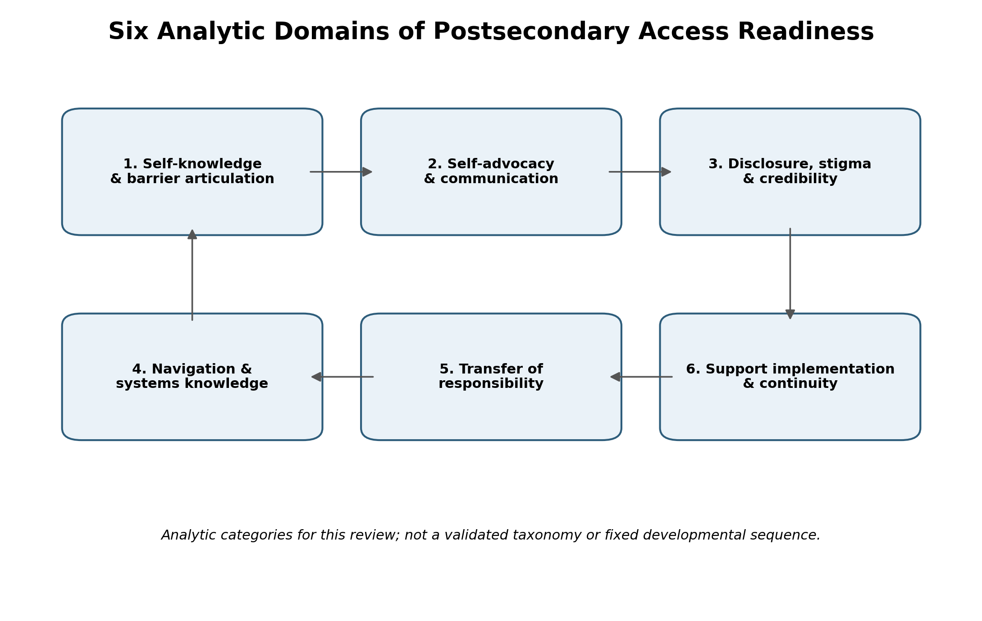
Figure 2. Six analytic domains were used to organize the structured review. Domains are interpretive categories, not a validated taxonomy or fixed sequence.
Domain 1: Self-Knowledge and Barrier Articulation
Current evidence supports the importance of self-awareness and the ability to communicate access-related difficulties, but does not establish "barrier articulation" as a single validated construct. Studies on self-advocacy and executive functioning suggest that students' ability to explain their needs is shaped by both individual variability and environmental conditions (Pfeifer et al., 2021; Southon, 2022). For the purposes of this review, barrier articulation is therefore treated cautiously as an analytic synthesis: the student's ability to describe what task, situation, or context is difficult and what support has previously helped, without assuming that a diagnosis alone determines the functional barrier.
Domain 2: Self-Advocacy and Communication
Self-advocacy is one of the strongest domains in the current evidence base for self-advocacy. Moore et al. (2024) described the development of self-advocacy as students transitioned from K-12 settings with substantial family and school support to higher-education contexts requiring greater self-awareness, assertiveness, and knowledge of rights and resources. Cho and Jones (2024) likewise identified uneven preparation in self-advocacy and disability law knowledge among college students registered with disability services. Pfeifer et al. (2021) found that self-advocacy among undergraduates with ADHD and/or specific learning disabilities was influenced by both student-level and environmental factors, with communication playing an important role.
The evidence also suggests that self-advocacy can be supported, rather than simply expected. Nieweglowski et al. (2025) reported that a six-week self-advocacy program for college students with disabilities was feasible and acceptable and produced preliminary improvements in confidence related to disclosure and requesting accommodations, although group differences were not observed for all self-advocacy and self-determination outcomes. Santhanam and Wilson (2024) further documented college-related self-advocacy challenges among autistic students compared to other groups. Together, these findings support treating self-advocacy as a developmental and contextual skill set, rather than an automatic consequence of college entry.
Domain 3: Disclosure, Stigma, and Credibility
For students with invisible disabilities, access can require decisions about whether, when, how, and to whom disability-related information should be disclosed. Kline and Davidson (2022) documented disclosure, hiding, and support experiences among college students with invisible illnesses and disabilities. Melián and Meneses (2022) found that disclosure could involve emotional risk and that administrative processes could become barriers, particularly for students concerned about stigma and credibility. Tontini and Moriña (2025) extended this evidence by showing that disclosure among university graduates with invisible disabilities is dynamic and contextual, shaped by trust, stigma, crisis, and the perceived need to access support.
This body of evidence is strong at the postsecondary level, but less direct evidence follows disclosure decision-making prospectively across the high-school-to-college transition. This review therefore treats disclosure as a documented postsecondary access need while explicitly avoiding claims that the same process unfolds identically before enrollment.
Domain 4: Navigation and Systems Knowledge
Transition also requires students to navigate different legal and institutional structures. Gartland and Strosnider (2023) summarize the key differences between secondary and postsecondary systems for students with learning disabilities, including changes in self-identification, documentation, and institutional responsibility. Cho and Jones (2024) found uneven knowledge of disability law and campus resources, while direct transition studies have described the bureaucratic and practical challenges associated with moving into higher education (Kim et al., 2021; Parsons et al., 2023).
These findings support understanding navigation as more than knowing that a disability services office exists. Students may need to identify the appropriate office, understand when to initiate contact, interpret procedures, communicate with multiple institutional actors, and know when a problem requires escalation. Navigation appears to be an interaction between student knowledge and the clarity, accessibility, and responsiveness of institutional systems.
Domain 5: Transfer of Responsibility
The transfer of responsibility from family- and school-supported processes to student leadership is directly represented in the transition literature. Moore et al. (2024) described evolving relationships with parents and caregivers as students learned to advocate for themselves in college. Kim et al. (2021) identified family support, transition programs, new expectations, and the balance between parental support and independence as important aspects of autistic students' adjustment to higher education. Parsons et al. (2023) similarly described transition and accommodation experiences requiring students to assume a more active role in postsecondary processes.
These findings argue against a binary model in which adults either manage the process or withdraw from it. A contextual developmental interpretation suggests that responsibility is more appropriately transferred through supported practice, with the student increasingly leading while retaining access to family, professional, and institutional support when needed.
Domain 6: Support Implementation and Continuity
The evidence base also distinguishes between obtaining accommodation and successfully using it. Studies on postsecondary accommodation use show that approved support may be used inconsistently, may encounter implementation barriers, or may require additional coordination and adjustment (Blasey et al., 2023; Edwards et al., 2022; Tufty et al., 2024). This domain is important because a student who successfully completes the initial disability-services process may still experience access problems if support is not implemented, is difficult to use, or does not meet the demands of a particular course or environment.
However, most current evidence in this domain is postsecondary rather than transition-specific. In the present manuscript, implementation and continuity are therefore treated as consequential postsecondary needs that become visible after transition, while deeper resource and implementation-gap analysis is reserved for subsequent work in this research stream.
Discussion
Across the six working domains, the strongest pattern is that the transition to postsecondary education changes both the environment and the student's role within the access process. Students may need to understand their own barriers, communicate with greater independence, decide whether to disclose invisible-disability-related information, navigate unfamiliar systems, and monitor whether support actually works. Simultaneously, these demands are not purely individual: institutional procedures, family relationships, faculty practices, social stigma, and the availability of understandable resources shape students' ability to exercise self-advocacy effectively.
This pattern is consistent with the contextual developmental interpretation. Self-advocacy is not best understood as a fixed trait that a student either possesses or lacks at the time of graduation. It develops through repeated opportunities to participate, communicate, make decisions, receive feedback, and gradually take on responsibility. Postsecondary systems can either support that development or make the process more difficult through fragmented procedures, unclear expectations, inaccessible information, or reliance on students to recognize and escalate problems without adequate guidance.
The findings also clarify the relationship between student preparation and institutional responsibility. Preparing students to advocate for themselves should not be a rationale for shifting all responsibility onto them. A stronger model combines increasing student agency with accessible systems, supportive relationships, clear escalation pathways, and continued opportunities for assistance. This distinction is especially important for students with non-apparent disabilities, for whom disclosure and credibility concerns may affect whether support is sought.
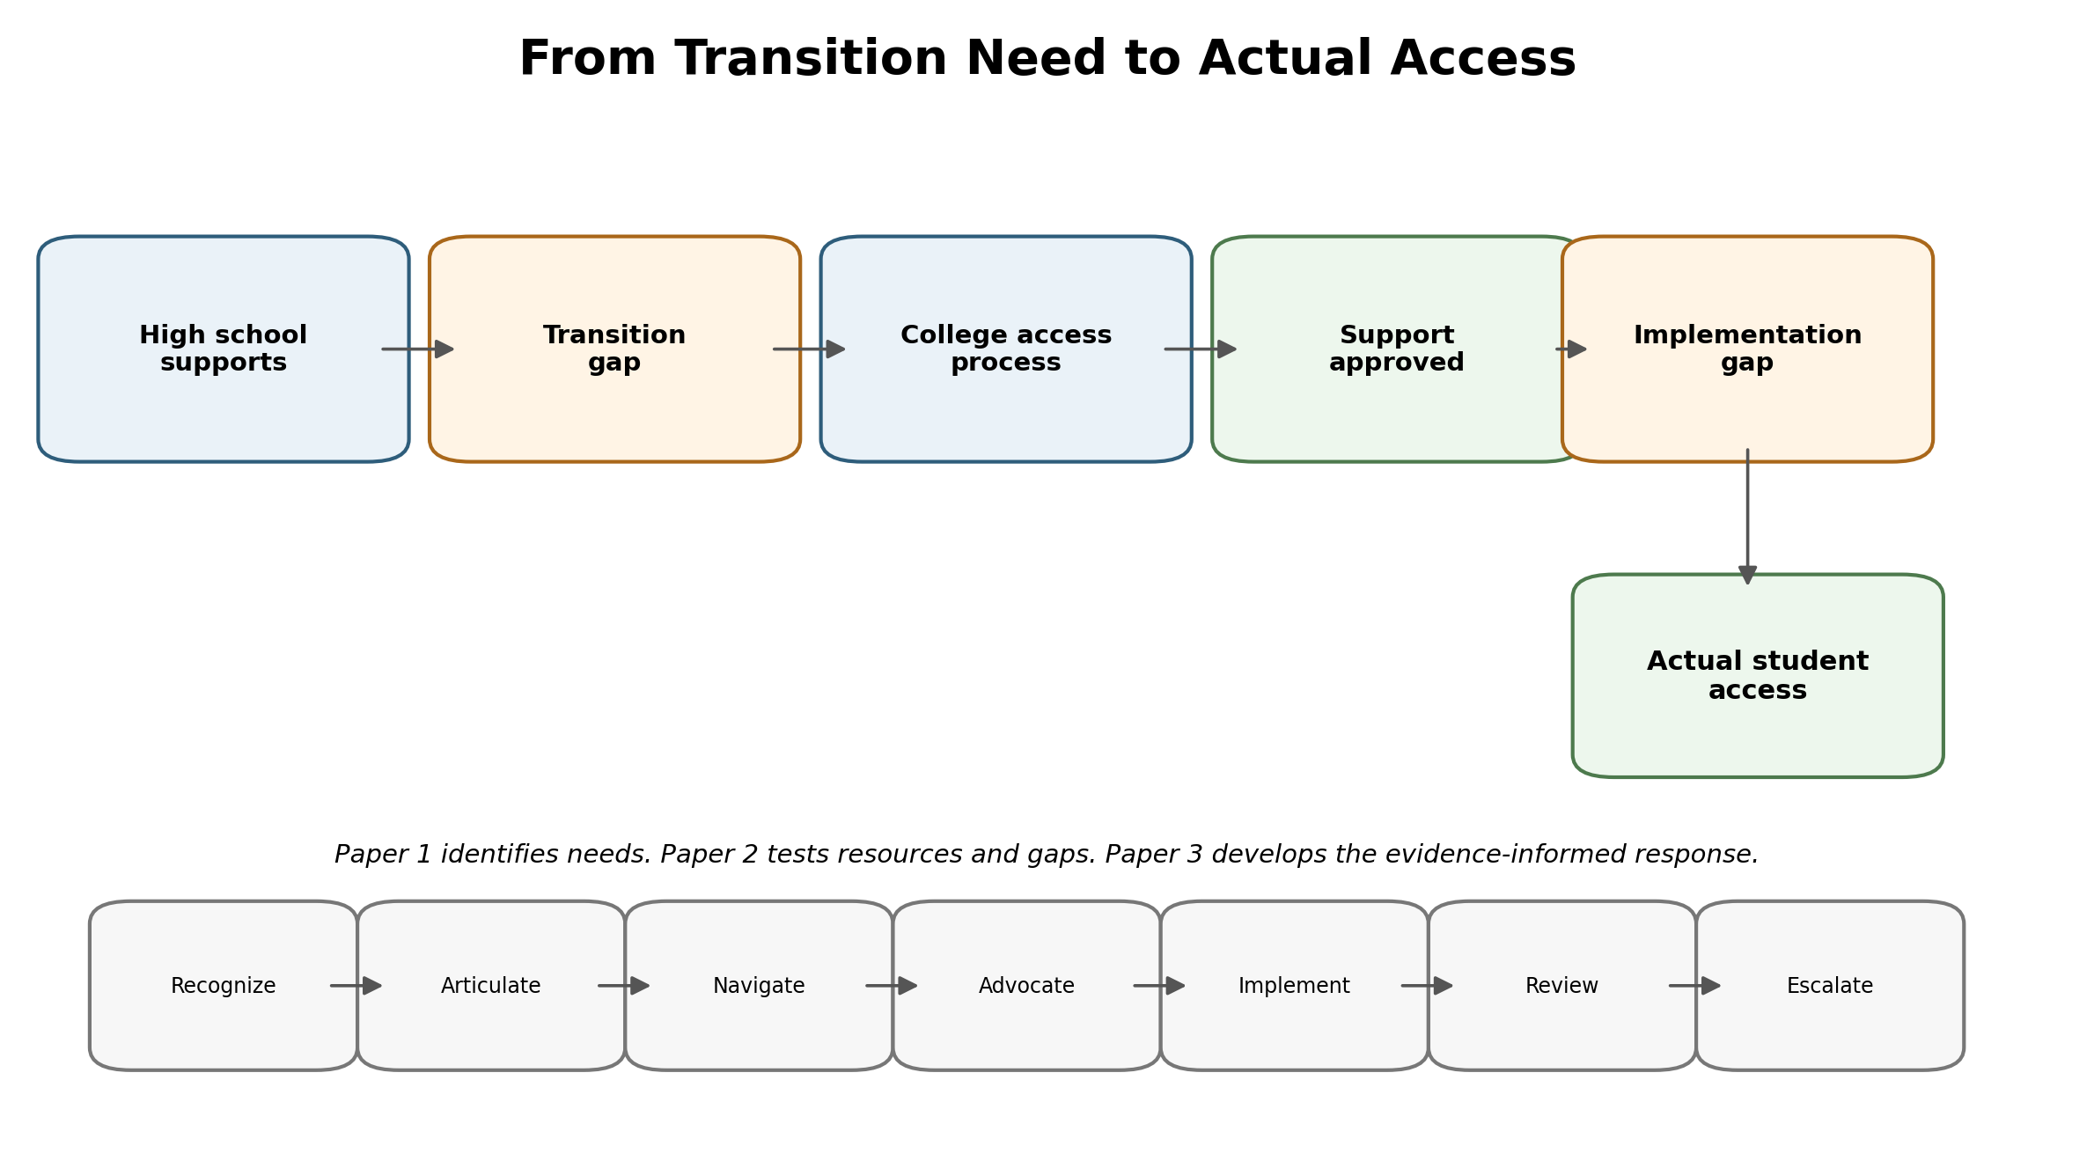
Figure 3. Conceptual bridge from transition preparation to actual access, separating transition and implementation gaps.
Implications for Families and Youth-Serving Professionals
Families, educators, extension professionals, and transition personnel can support preparation by gradually shifting responsibility for describing needs, locating resources, asking questions, and participating in meetings. Practice should focus on what the student increasingly leads, not on whether the student can manage every part of the process independently.
Implications for Postsecondary Institutions
Postsecondary institutions should not interpret student self-advocacy requirements as evidence of neutral institutional design. Clear procedures, accessible information, coordinated services, and responsive problem-solving are central to equitable access. The evidence supports continued attention to how students learn the system, how disability-related information is communicated, and how institutions respond when accommodation is difficult to obtain or implement.
Future Research
Technology was intentionally not the central focus of this review; the needs assessment establishes the problem before evaluating a technological solution. Future research can examine whether existing digital, assistive-technology, or generative-AI resources address the documented needs and where gaps remain. The present synthesis supports investigating technology only as a potential means of reducing barriers in communication, navigation, or implementation; it does not establish that any specific technology improves transition outcomes.
Limitations
Methodological Limitations
- This review is intentionally structured and purposive rather than systematic; it did not use a pre-registered protocol, exhaustive database searching, duplicate independent screening, or formal study-quality appraisal.
- Accordingly, the review cannot establish exhaustive coverage or pooled prevalence estimates, and the six domains should be interpreted as an analytic synthesis of the retained evidence rather than a universal taxonomy.
- Design classifications in Table 1 were drawn from available synthesis notes and should be verified against source articles prior to submission.
Evidentiary Limitations
- The evidence base includes heterogeneous disability groups, institutional contexts, and study designs, limiting direct comparison across domains.
- Several strong sources examine students after they enter higher education rather than prospectively following them across the transition.
- Evidence specific to non-apparent disabilities is stronger for disclosure and postsecondary experience than for every transition domain.
- Some direct transition studies are disability-specific (particularly autism or learning disability research), which limits generalization to other disability groups.
Final conclusions therefore distinguish direct transition evidence from postsecondary-only evidence and avoid treating experiences from one disability group as universal. A future systematic or scoping review could extend this work using a pre-registered protocol, exhaustive database searching, duplicate independent screening, and formal study-quality appraisal.
Conclusion
The reviewed evidence suggests that preparing students with non-apparent disabilities for postsecondary education requires more than transferring documentation or explaining the legal differences between school systems. Transition readiness includes developing self-knowledge, communication and self-advocacy, disclosure decision-making, systems navigation, increasing student leadership, and the ability to recognize when approved support is not functioning as intended. These needs are shaped by the environment and relationships surrounding the student. A developmental approach therefore supports increasing ownership while preserving accessible systems and human support. This needs assessment provides a foundation for subsequent analyses of existing resources, remaining gaps, and evidence-informed responses.

References
Arnett, J. J. (2000). Emerging adulthood: A theory of development from the late teens through the twenties. American Psychologist, 55(5), 469–480. https://doi.org/10.1037/0003-066X.55.5.469
Blasey, J., Wang, C., & Blasey, R. (2023). Accommodation use and academic outcomes for college students with disabilities. Psychological Reports, 126(4), 1891–1909. https://doi.org/10.1177/00332941221078011
Bronfenbrenner, U., & Morris, P. A. (2006). The bioecological model of human development. In W. Damon & R. M. Lerner (Eds.), Handbook of child psychology: Vol. 1. Theoretical models of human development (6th ed., pp. 793–828). Wiley.
Cho, J. I., & Jones, K. (2024). How do college students with disabilities do? Law, self-determination, self-advocacy, and campus resources. Journal of the Scholarship of Teaching and Learning, 24(3), 68–86. https://doi.org/10.14434/josotl.v24i3.35703
Edwards, M., Poed, S., Al-Nawab, H., & Penna, O. (2022). Academic accommodations for university students living with disability and the potential of universal design to address their needs. Higher Education, 84(4), 779–799. https://doi.org/10.1007/s10734-021-00800-w
Gartland, D., & Strosnider, R. (2023). Considerations for transition from high school to postsecondary education. Learning Disability Quarterly, 46(3), 230–242. https://doi.org/10.1177/07319487221111099
Kim, S. Y., Crowley, S., & Bottema-Beutel, K. (2021). Autistic undergraduate students' transition and adjustment to higher education institutions. Research in Autism Spectrum Disorders, 89, Article 101883. https://doi.org/10.1016/j.rasd.2021.101883
Kline, B., & Davidson, D. L. (2022). College students with invisible illnesses and disabilities: Disclosure, hiding, and support. College Student Affairs Journal, 40(3), 121–135. https://doi.org/10.1353/csj.2022.0030
Melián, E., & Meneses, J. (2022). Getting ahead in the online university: Disclosure experiences of students with apparent and hidden disabilities. International Journal of Educational Research, 114, Article 101991. https://doi.org/10.1016/j.ijer.2022.101991
Moore, A. M., Vaccaro, A., Newman, B. M., Daly-Cano, M., & Brandis Ruise, B. (2024). "I shouldn't have to rely on them anymore": College students with disabilities on the journey toward self-advocacy. Journal of The First-Year Experience & Students in Transition, 36(1), 93–112.
Nieweglowski, K., Qin, S., & Ko, E. (2025). A randomized controlled trial for self-advocacy intervention in college students with disabilities. Rehabilitation Psychology, 70(3), 255–266. https://doi.org/10.1037/rep0000583
Parsons, J. M., McColl, M. A., Martin, A., & Reynard, D. (2023). Transition and accommodation experiences of students with disabilities: A qualitative study. Journal of Postsecondary Education and Disability, 36(2), 179–192.
Pfeifer, M. A., Reiter, E. M., Cordero, J. J., & Stanton, J. D. (2021). Inside and out: Factors that support and hinder the self-advocacy of undergraduates with ADHD and/or specific learning disabilities in STEM. CBE—Life Sciences Education, 20(2), Article ar17. https://doi.org/10.1187/cbe.20-06-0107
Santhanam, S. P., & Wilson, K. (2024). A comparison of autistic and non-autistic college students' perceived challenges and engagement in self-advocacy. American Journal of Speech-Language Pathology, 33(3), 1471–1484. https://doi.org/10.1044/2024_AJSLP-22-00381
Southon, C. (2022). The relationship between executive function, neurodevelopmental disorder traits, and academic achievement in university students. Frontiers in Psychology, 13, Article 958013. https://doi.org/10.3389/fpsyg.2022.958013
Tontini, L., & Moriña, A. (2025). Disclosure dilemmas: Experiences of university graduates with invisible disabilities. International Journal of Educational Research, 133, Article 102694. https://doi.org/10.1016/j.ijer.2025.102694
Tufty, L. M., Gallagher, V. T., Oddo, L., Vasko, J., Chronis-Tuscano, A., & Meinzer, M. (2024). Academic accommodations and functioning in college students with attention-deficit/hyperactivity disorder: Limitations, barriers, and suggestions for collaborators. Journal of Postsecondary Education and Disability, 37(1), 35–46.
Vygotsky, L. S. (1978). Mind in society: The development of higher psychological processes (M. Cole, V. John-Steiner, S. Scribner, & E. Souberman, Eds.). Harvard University Press.

